Phse 5 part c
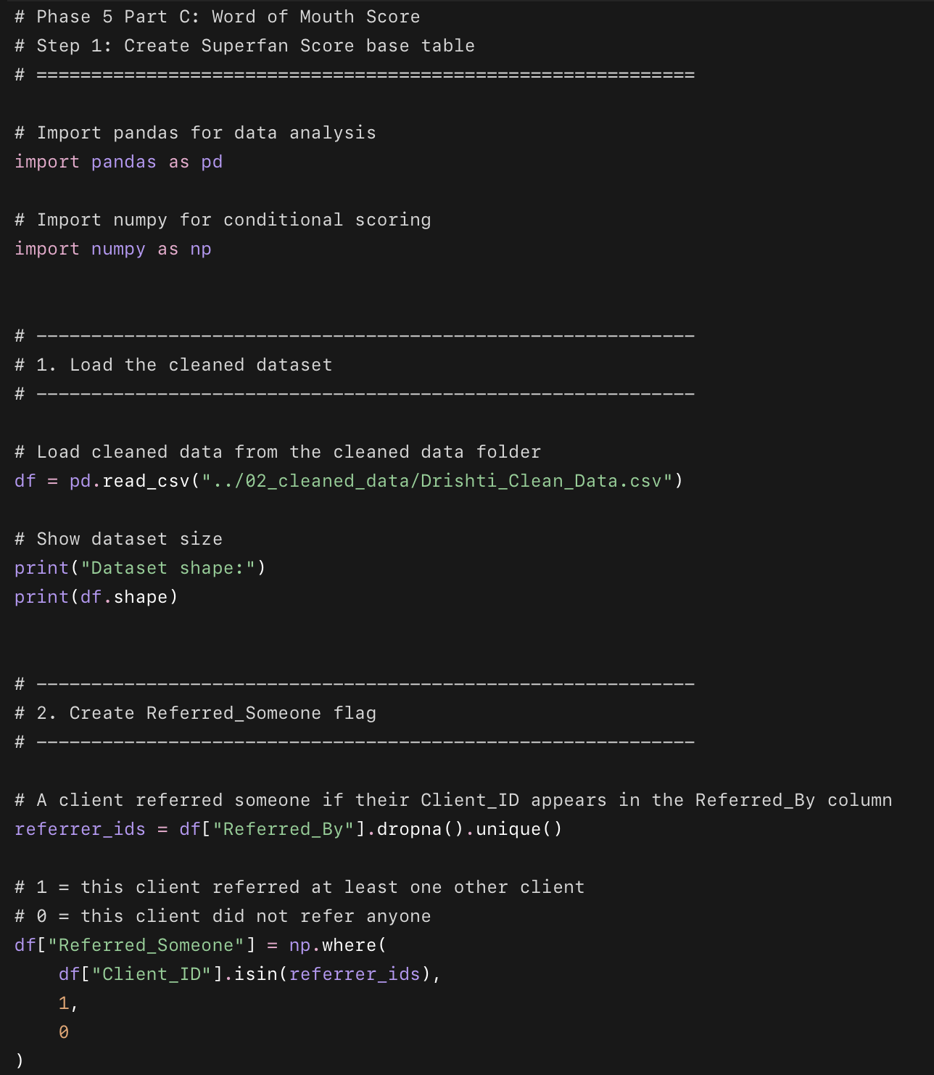
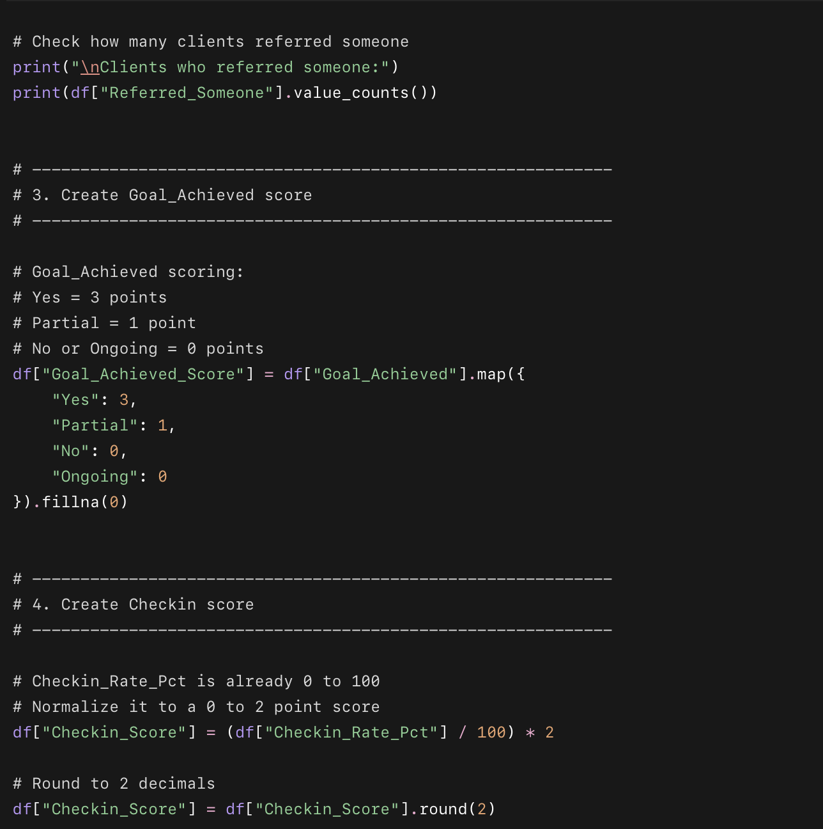
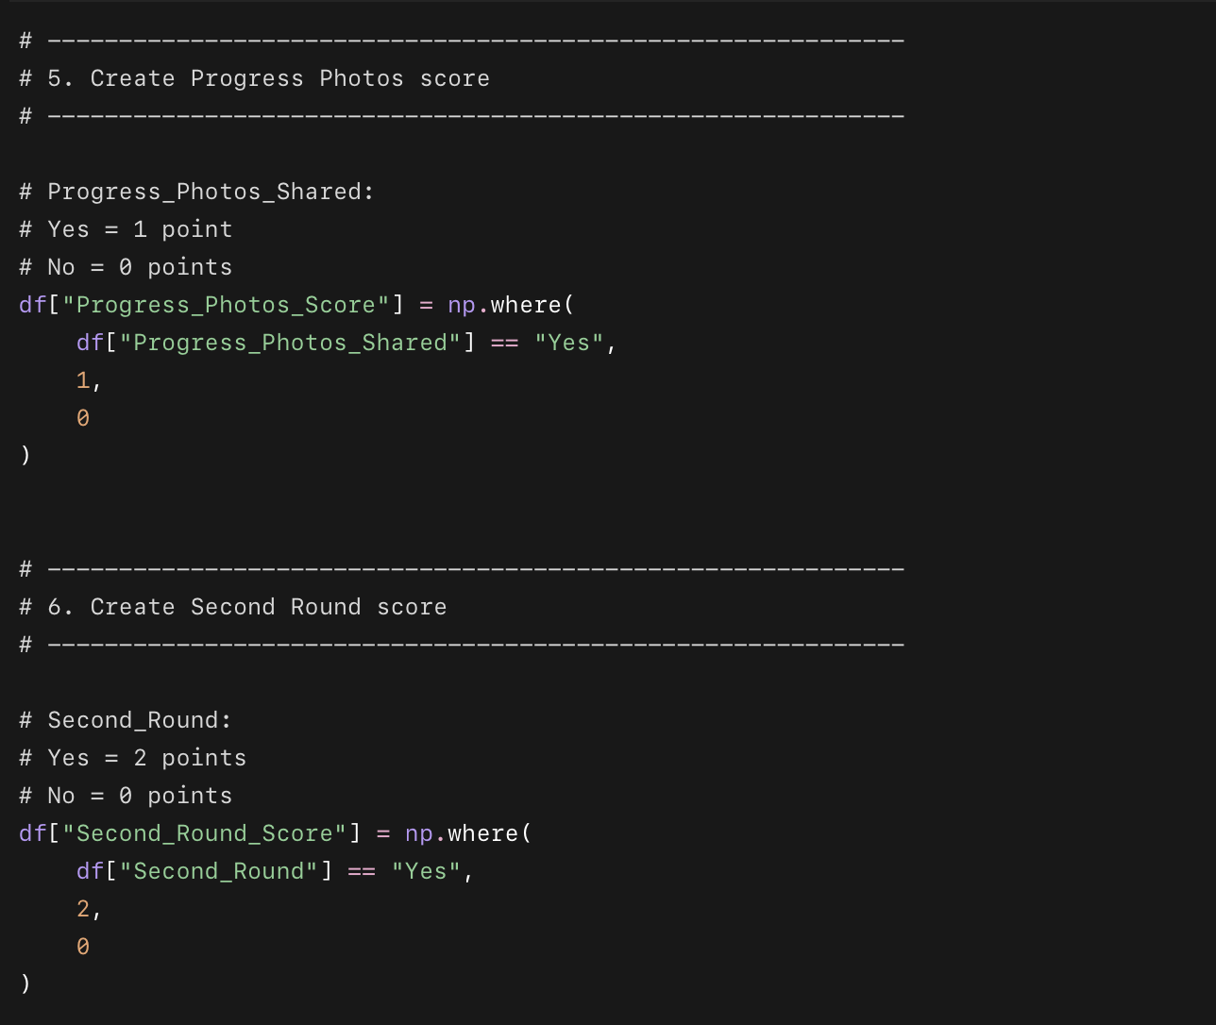
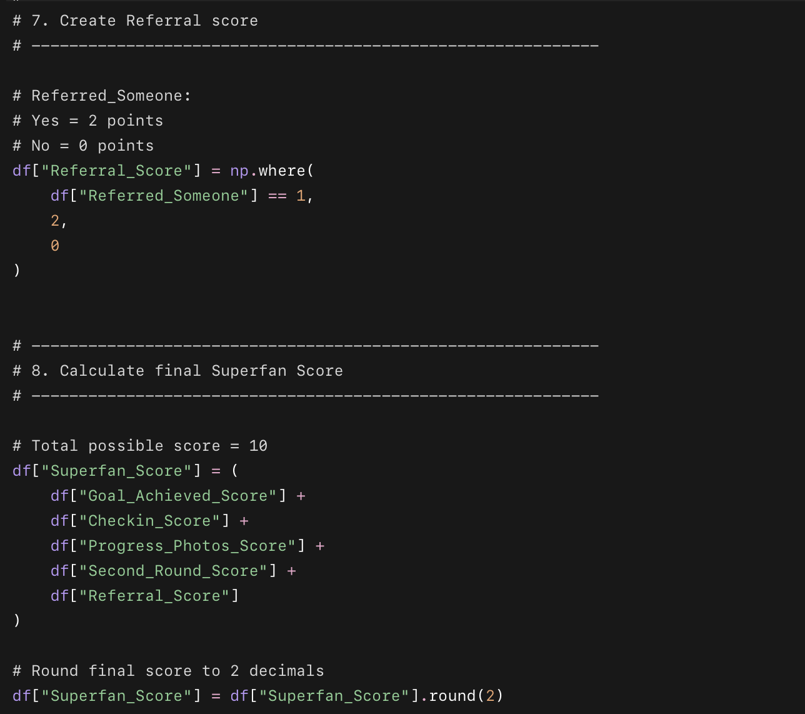
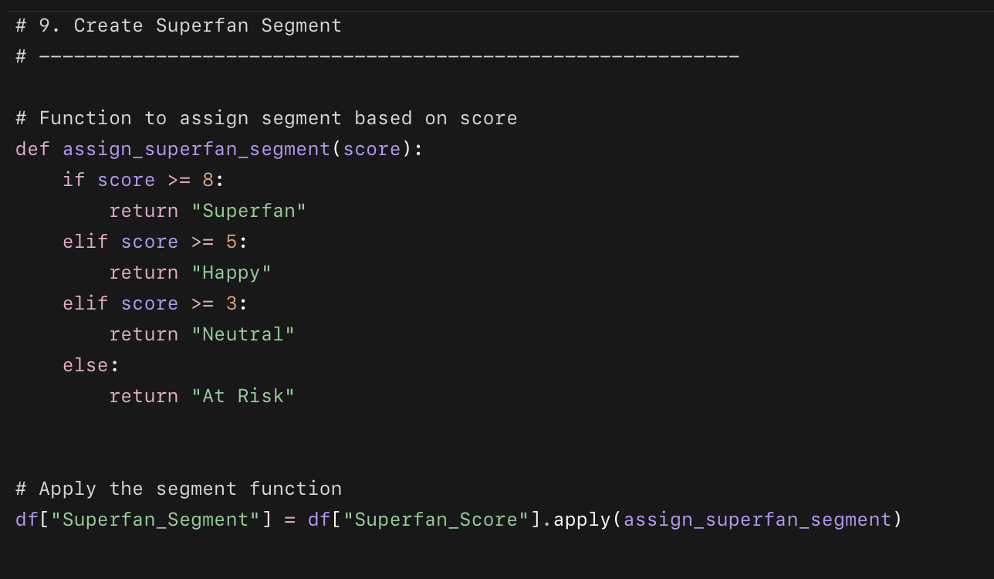
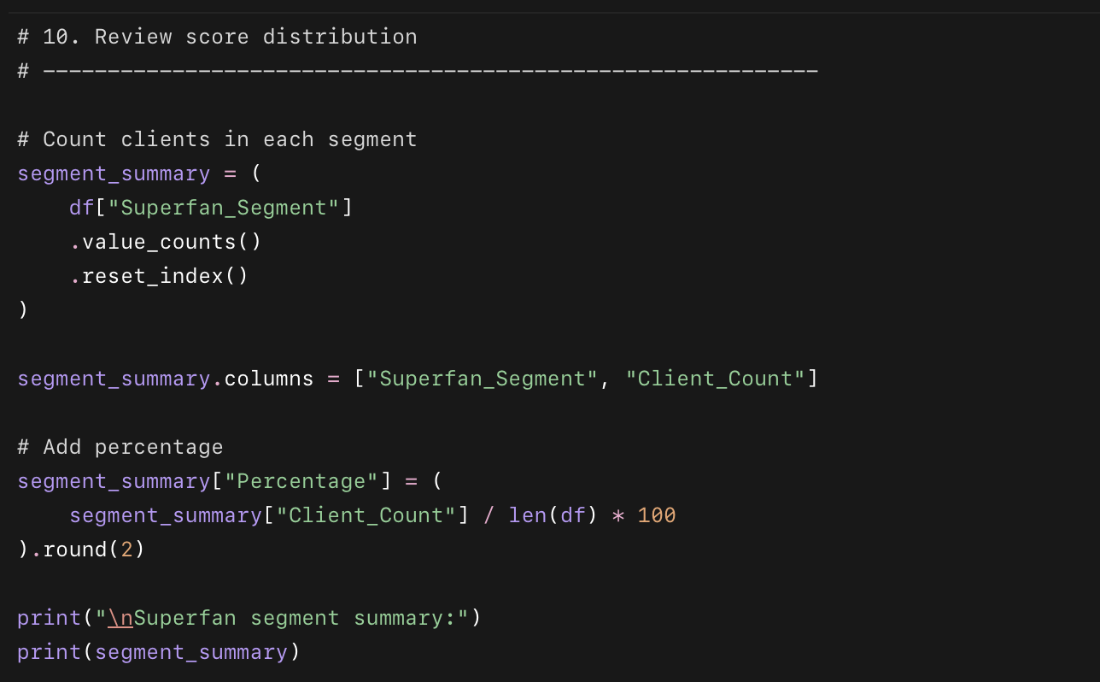
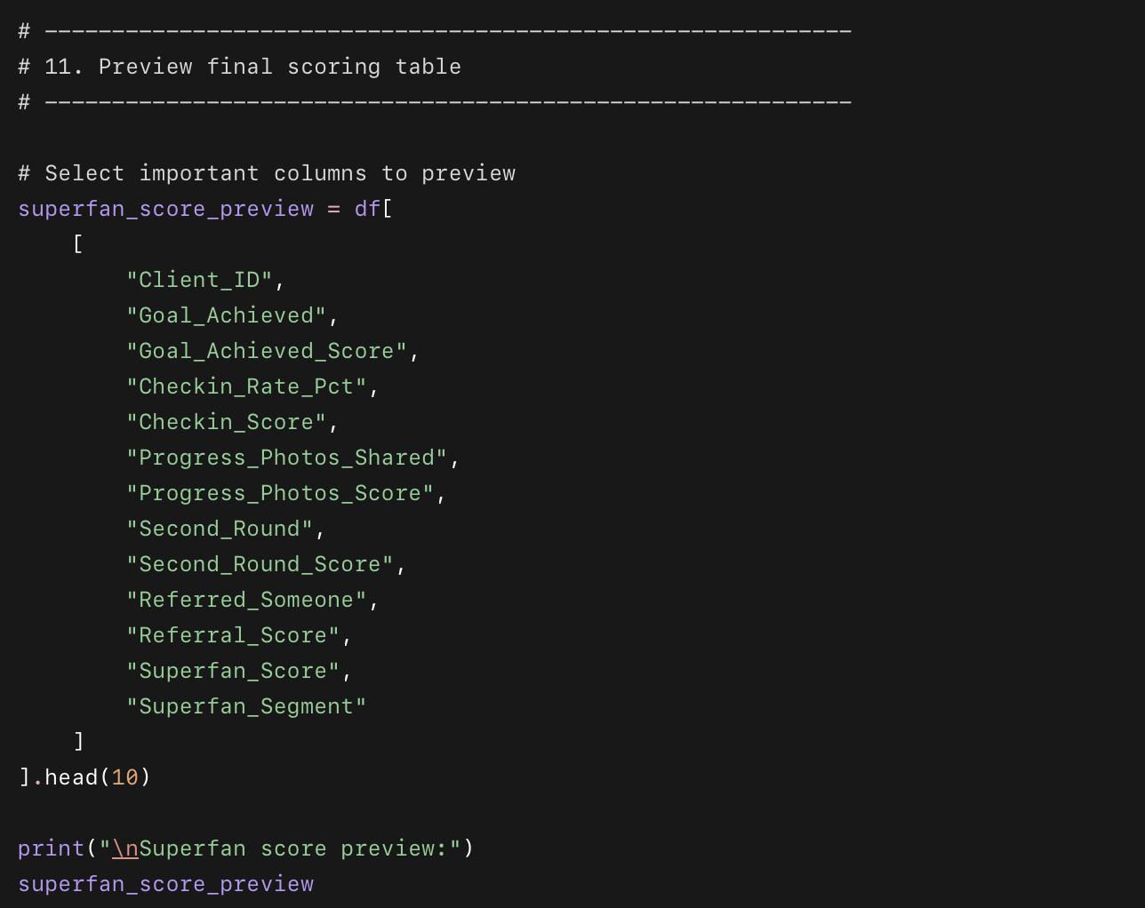

What this code does
- Loads the cleaned client dataset.
- Finds which clients referred someone else.
- Creates score points for:
  - goal achievement
  - check-in rate
  - progress photo sharing
  - second round signup
  - referral behavior
- Adds everything into a final Superfan_Score from 0 to 10.
- Groups every client into a word-of-mouth segment.

Why we are doing this
This turns word of mouth into a measurable business score. Instead of only saying “happy clients refer people,” we are building a system that identifies which clients are most likely to become promoters, repeat clients, and referral drivers.
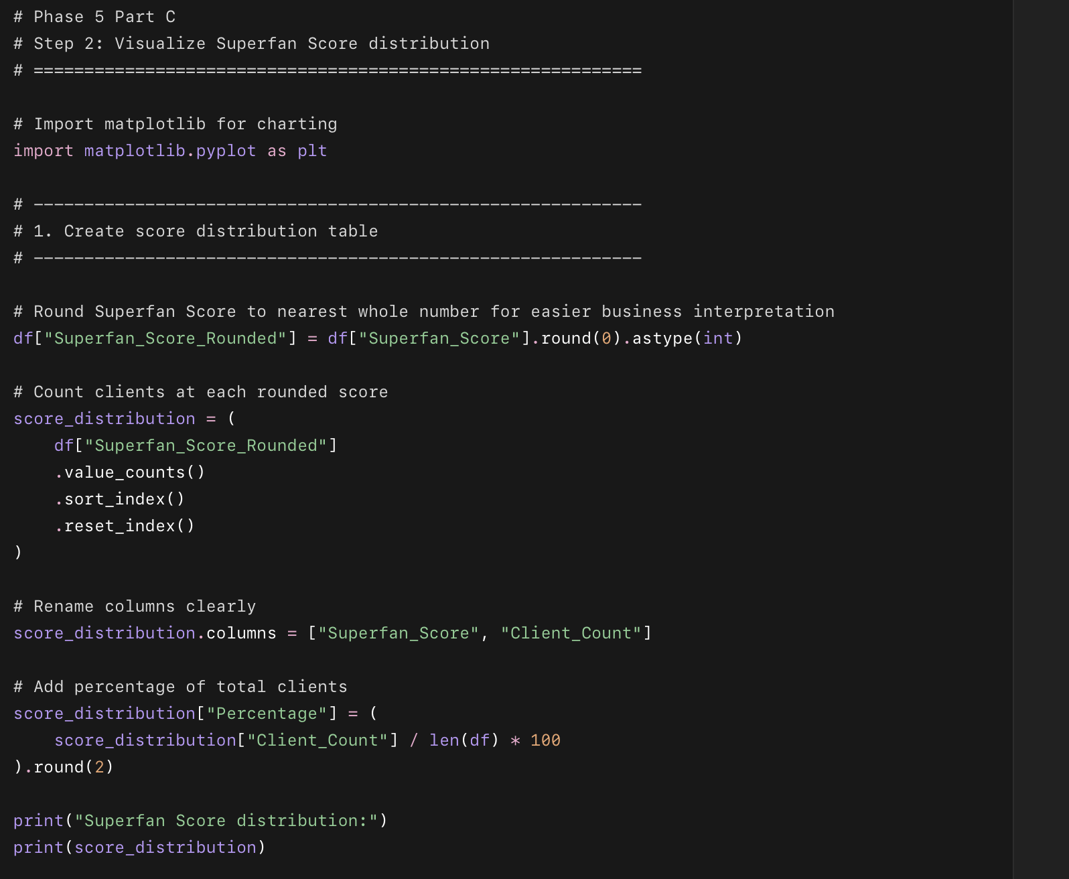
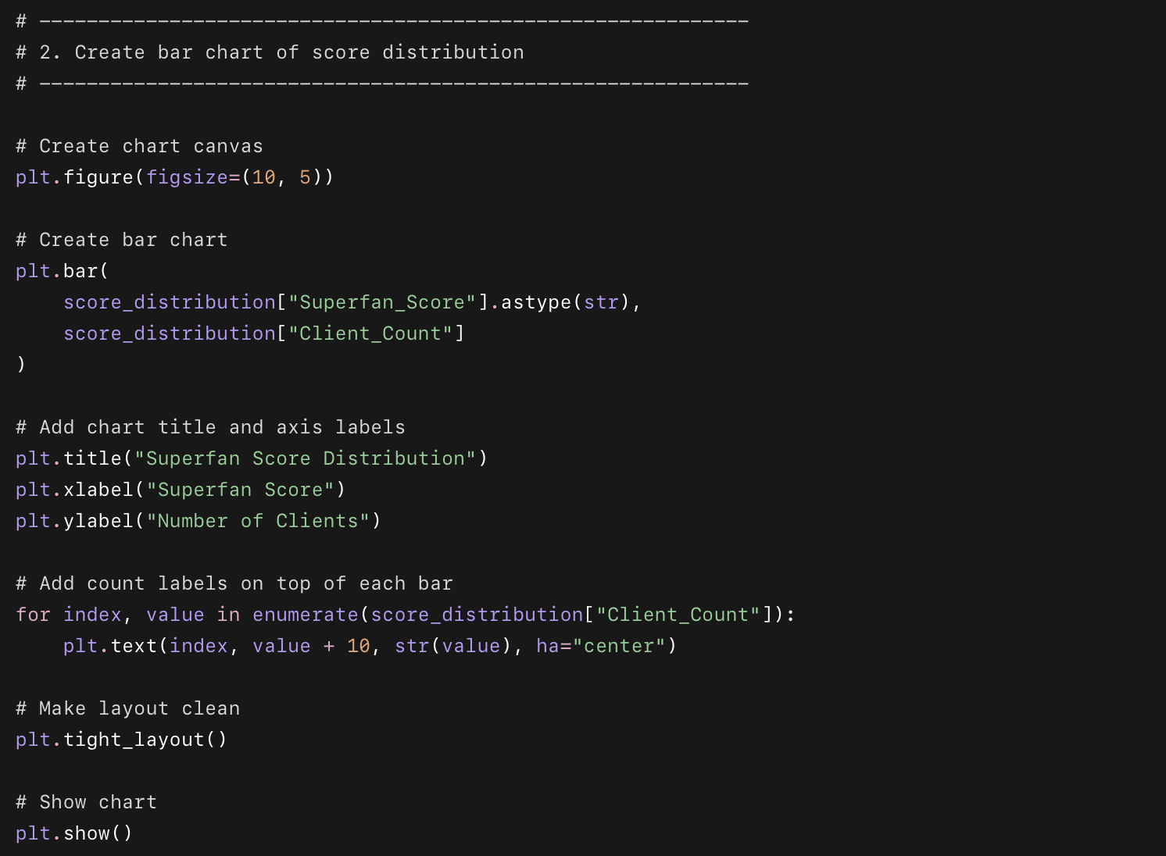

What this code does
- Rounds each client’s Superfan Score to a whole number.
- Counts how many clients fall into each score level.
- Calculates the percentage of clients at each score.
- Creates a bar chart showing the score distribution.

Why we used this code
This chart shows how strong the client base is for word of mouth. If many clients are in the middle scores, Drishti has a clear opportunity to move them upward into Superfan territory.
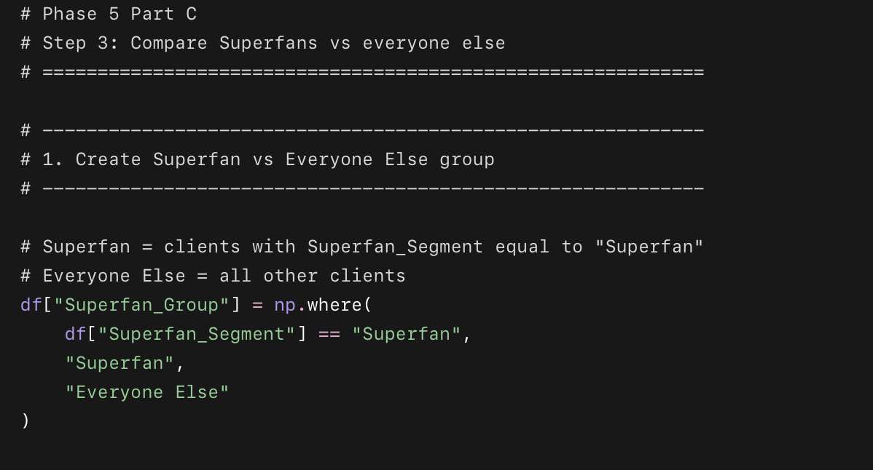
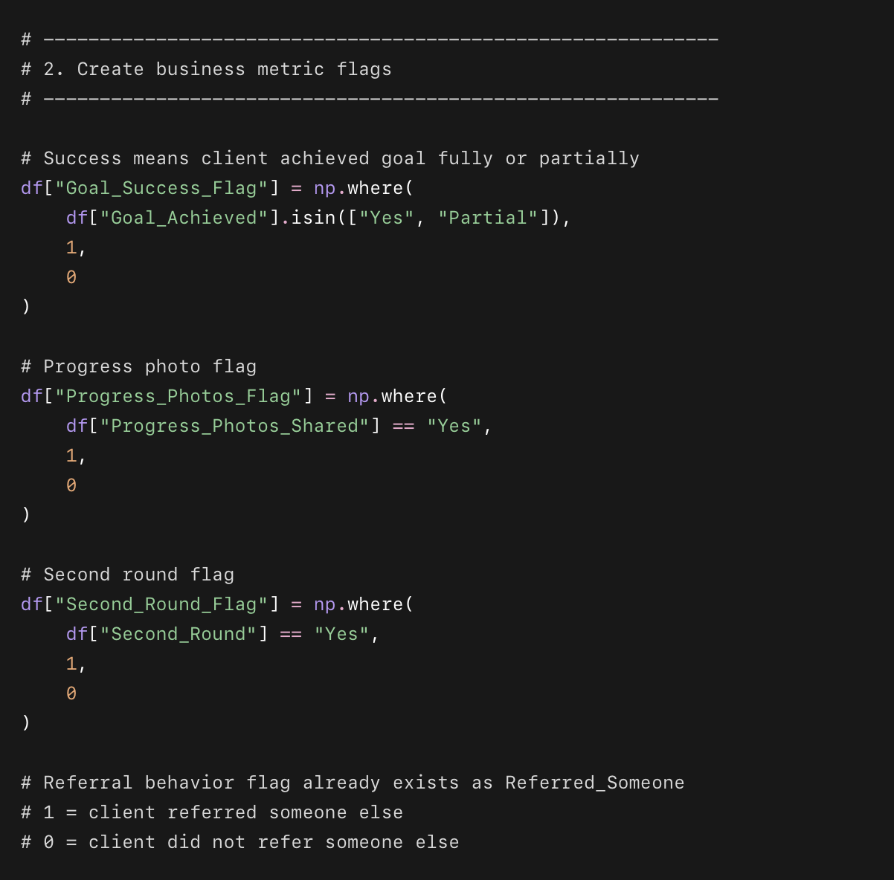
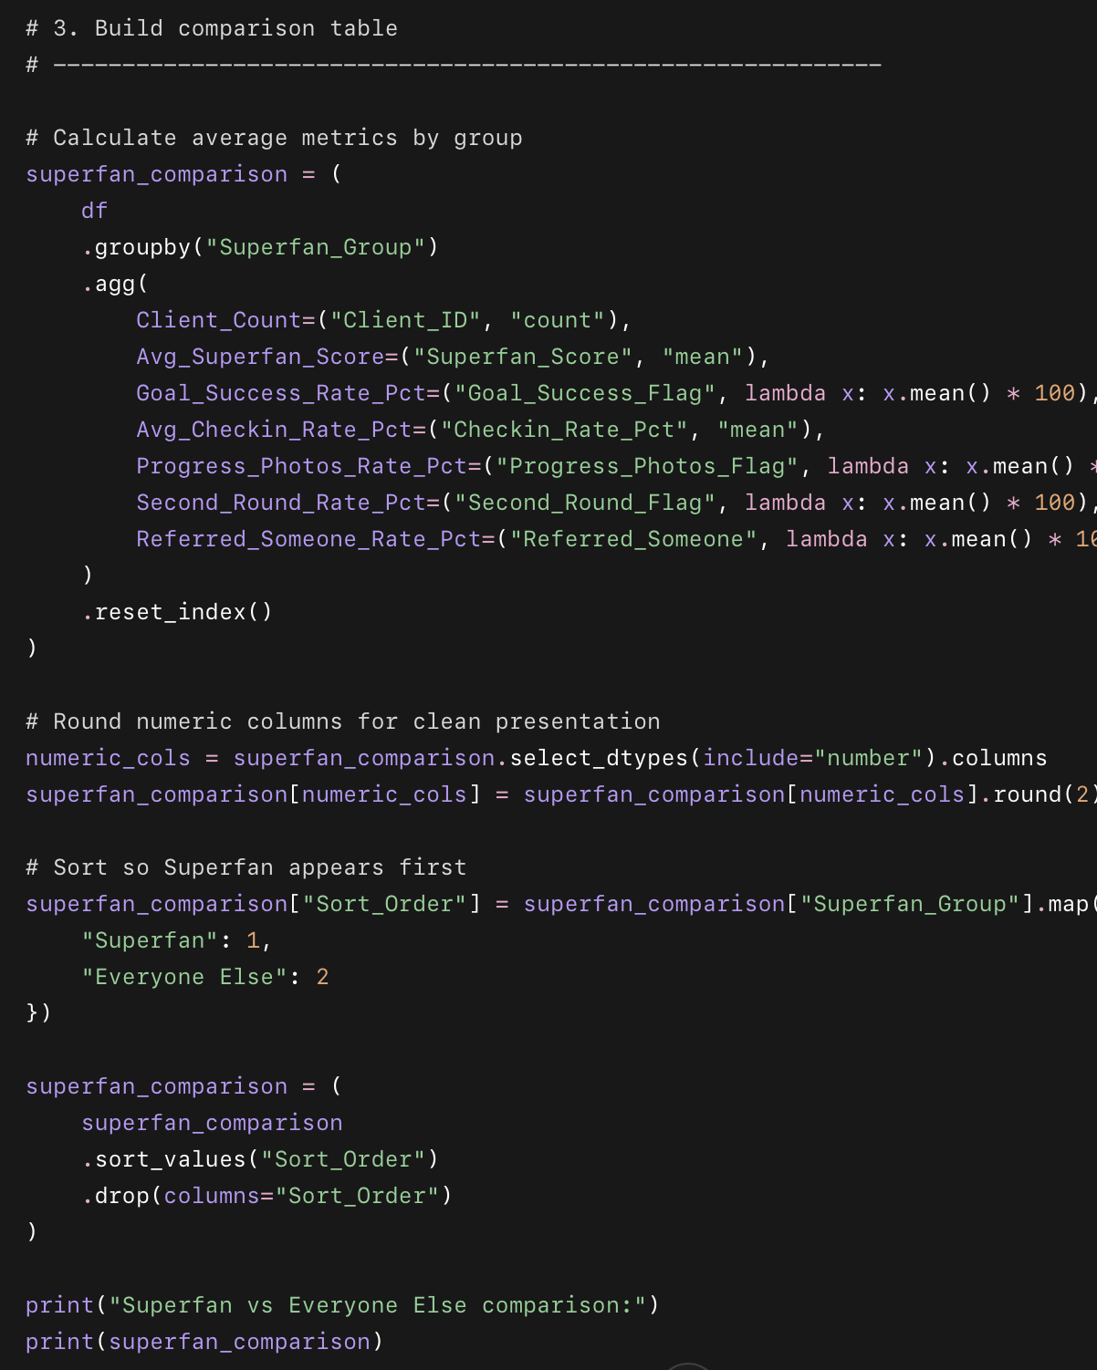
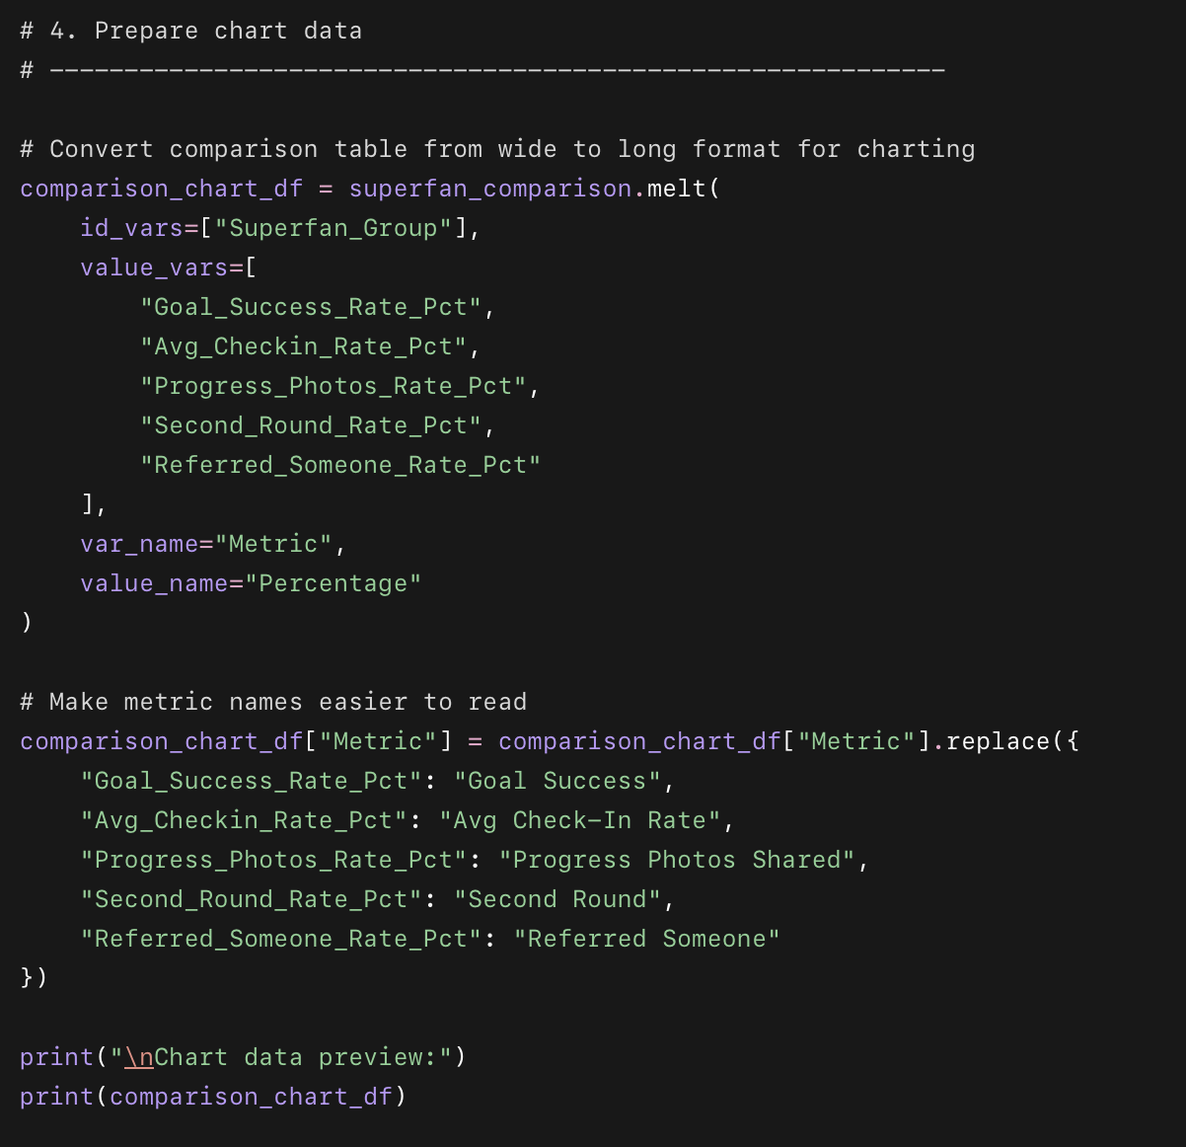
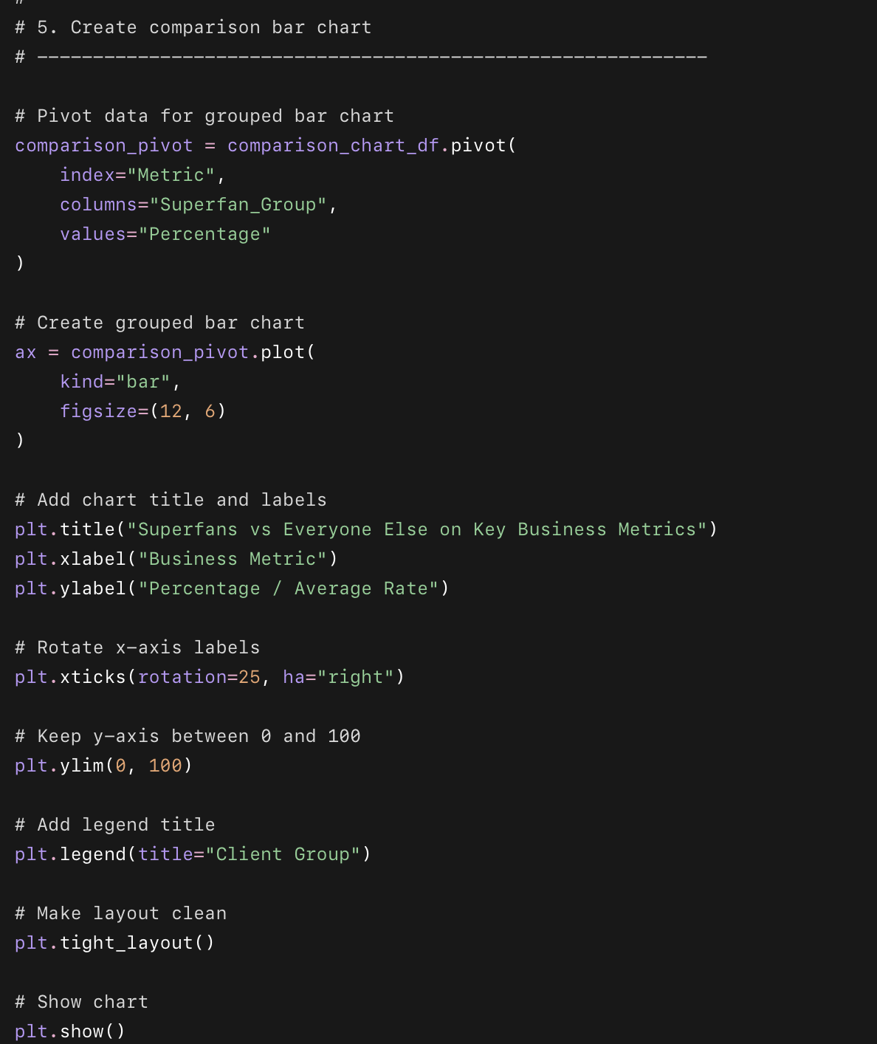

What this code does
- Creates a Superfan_Group column:
  - Superfan
  - Everyone Else
- Creates clean business metric flags.
- Calculates Superfan vs everyone else comparison metrics.
- Builds a comparison table.
- Creates a grouped bar chart comparing both groups on 5 important business metrics.

Why we used this code
This shows what makes Superfans different. Instead of guessing why some clients become referral drivers, we compare their actual behavior against everyone else.
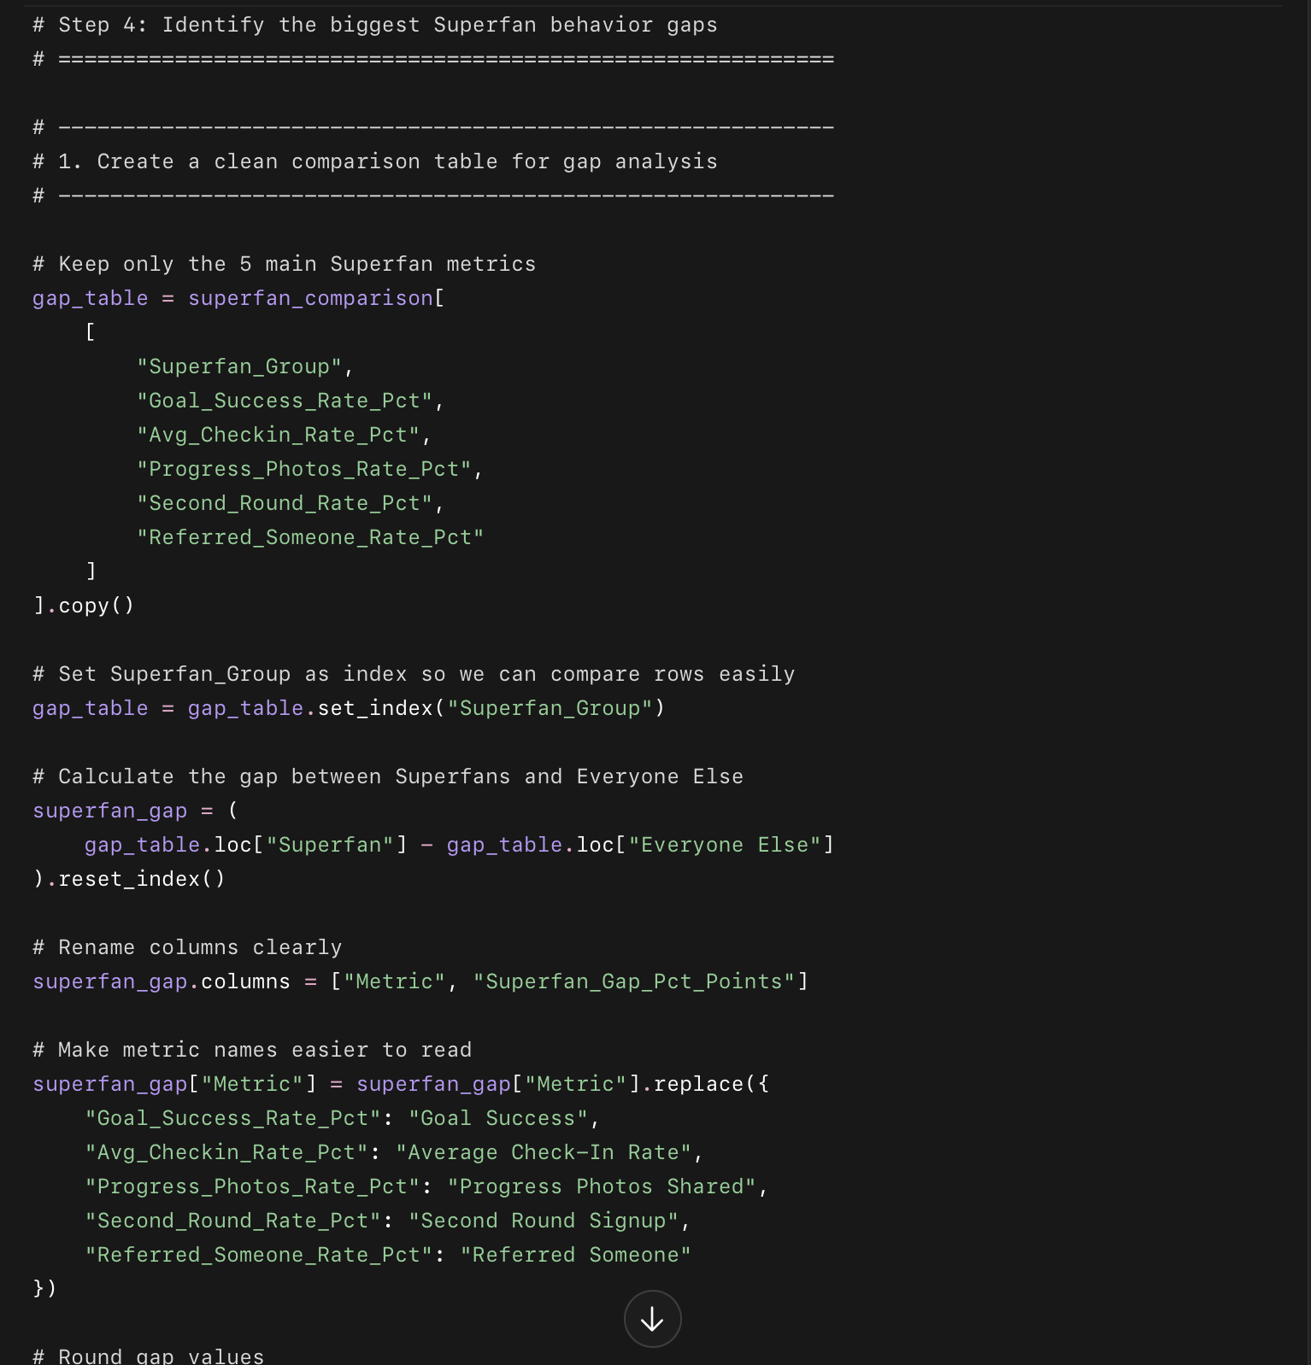
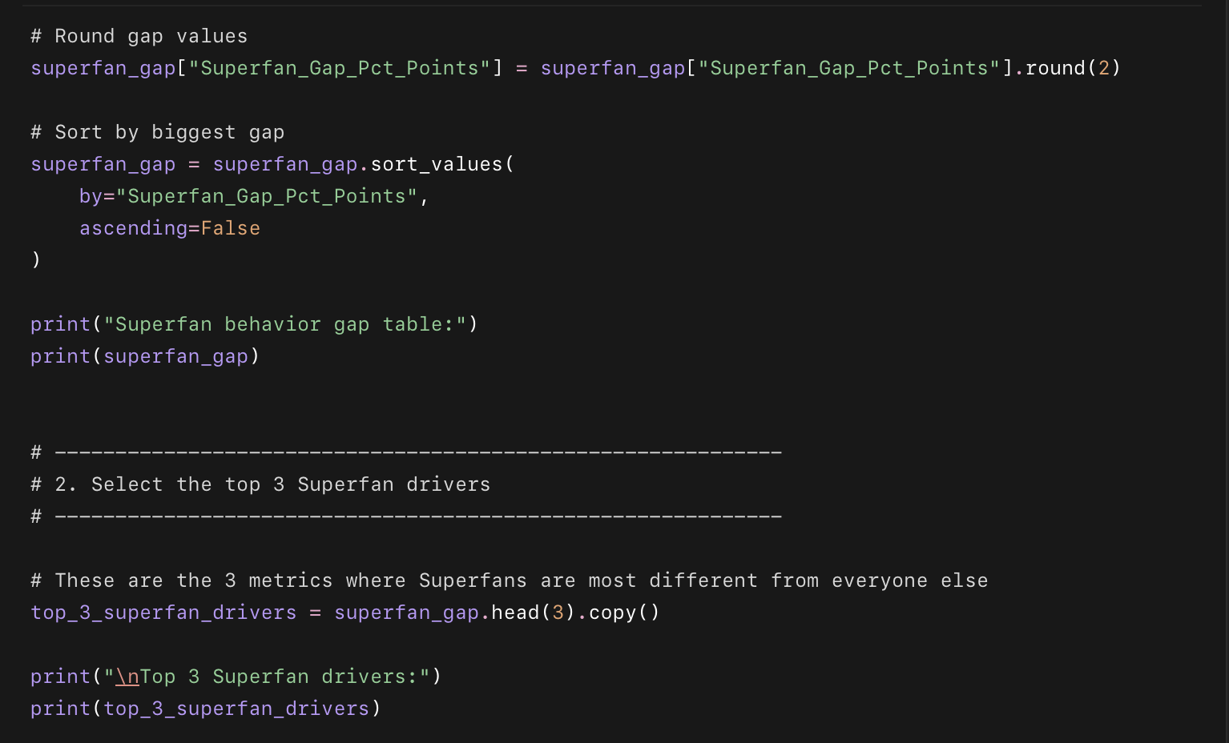
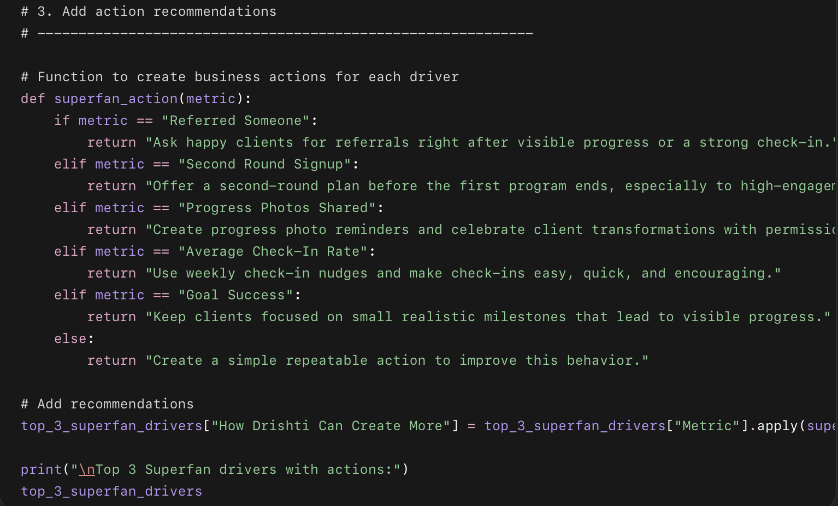
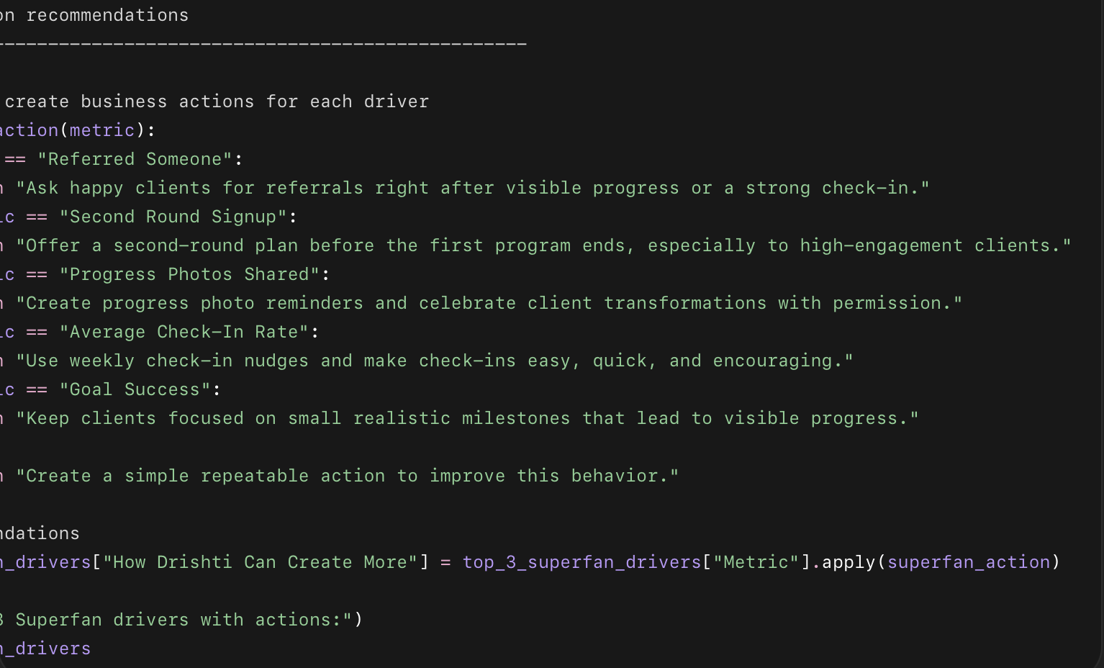

What this code does
- Uses the Superfan vs everyone else comparison table.
- Calculates the percentage-point gap for each key metric.
- Sorts the metrics by biggest difference.
- Selects the top 3 strongest Superfan drivers.
- Adds practical action recommendations for Drishti.

Why we used this code
This turns the Superfan analysis into a clear business strategy. Instead of saying “Superfans are better,” we identify exactly which behaviors separate them and what Drishti can do to create more of them.

